**TASK-03**

**Golf average score for three games.**

**EXPLANATION:**

The program takes input from the user as three game scores of golf and then gives the average as output.

**INPUT:**

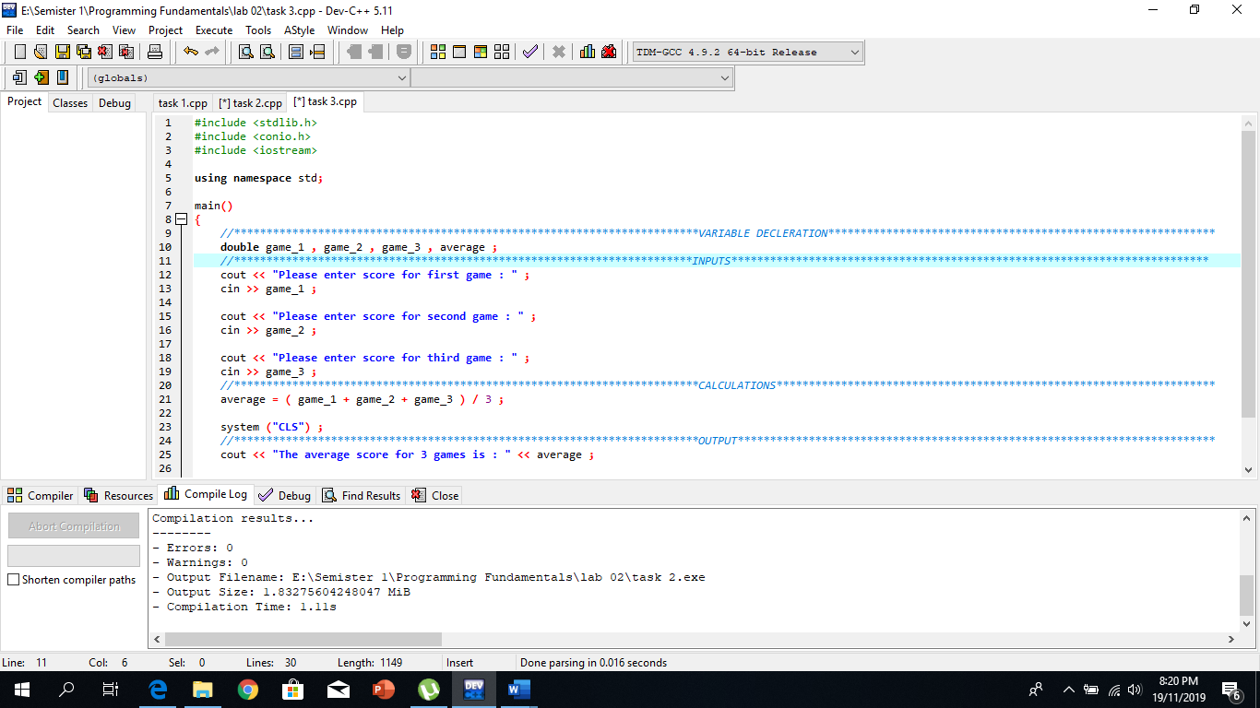

**OUTPUT:**

